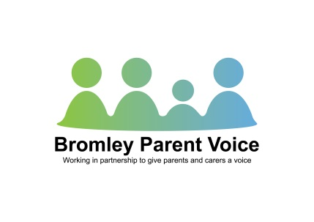
10th March 2014
Dear Parent/ Carer
A number of you attended our January meetings around the Short Breaks consultation.
During these meetings many parents were concerned about potential threat to current provision. It was felt at that time that a way forward would be for parents to contact their local MP and/or councillors. Bromley Parent Voice said they would provide a template letter for this.
Our primary focus in January was to ensure we put in a robust report in time for the consultation deadline. We also arranged to meet with LA officials prior to the closing date of the consultation.
This meeting allowed open discussion of issues and we received some very positive feedback on how the LA are trying to ensure good short break provision for families.
To that end BPV have been invited to a follow up meeting to look at Bromley’s strategy on Short Breaks which is being written following the consultation. We have also been asked to provide parent representatives to be involved in the commissioning of the additional Short Break contracts for April-September 2014 and the group based provision from September 2014.
All of the above is welcomed by BPV. The LA are keen to ensure good quality provision is available for families. There are financial considerations, which is inevitable in the current climate. At this time the budget for 2014/15 is yet to be set.
A recent newsletter from Riverside has worried parents about the continuation of this provision for short breaks. The LA are keen that this level of support continues within Bromley and are looking for ways to ensure such. Any commissioned service, where the contract is due for renewal, has to undergo tendering in a fair and transparent manner. Short Break provision currently provided by Riverside is one such contract. At this juncture nobody is in a position to pre-empt the outcome of the tender process or indicate how this service may be provided.
At this juncture we feel it is no longer necessary to ‘lobby’ MPs and/or councillors and we do not perceive a need going forward.
Once we have more news regarding the outcome of the consultation, we will disseminate the information to yourselves.
Yours sincerely,
Rosalind Luff (Chair BPV)

